

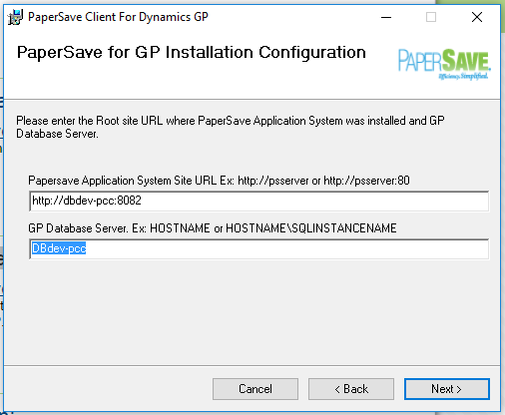

Make sure user is out of GP and all office products.

After installation run GP as administrator to process the cnk.